Mathematics


Items highlighted in yellow are tasks for you to complete
Items in Blue italics are help tips

113 Level 3 Mathematics Quiz

Question 1

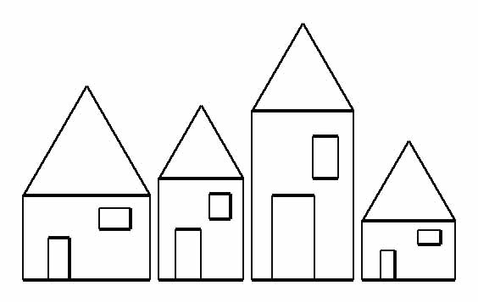
How many sevens are needed to number all the houses in a street from 1 to 100?
Answer:

Question 2

3 | 4 | 7 | 11

Look at this pattern
Now complete this one

4 |  |  | 20

(The rule is the same)

Answer:

Question 3

The A League

Cannington Crows, Bullcreek Tigers, Rossmoyne Blues, Bateman Bats and Willetton play in a soccer tournament. Each team must play every other team once. How many games must be played?

adidas

Answer:
Question 4

I am thinking of a number…

I multiply it by 3
Then subtract 13
Then add 5
And my answer is 25

What number am I thinking of?

Answer:

Question 5

Make $9 by using the same number of 10c coins, 20c coins, 50c coins and $1 coins.

$1
50c
20c
10c

Answer:

Question 6

The sum of 2 numbers is 80. What is the largest value that their product can be?

? + ? = 80
? × ? = ?

Answer:

Question 7

Magic Triangle
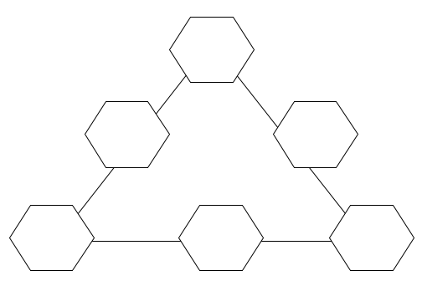
Arrange the numerals 1 to 6 in the triangle so that the sum of the three numbers along each side is 12.

Answer:

Question 8

Complete this multiplication.

345
× 2
- 5

Answer:

Question 9

XII
IX
VI
XII
VI
III
III
IX

Through what angle does the minute hand of a clock move between 1.40pm and 2.15pm on the same afternoon?
Answer:

Question 10

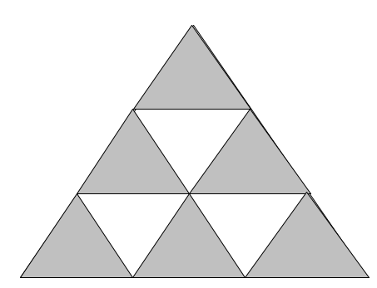
How many triangles?
Answer:

Question 11

1c | 2c | 4c
8c | _ | _
_ | _ | _

I have a board with 9 squares. I place 1 cent on the first square, 2 cents on the second square, 4 cents on the next square… until all 9 squares are full.

How much money is there on the board?

Answer:

Question 12

5
3
9
7
-
8
13
1
×
+
÷
-
5
11
×
4
+
÷

Find a path to the centre of the maze so that the final total is 50.

Answer:

Need help just ask

